**2.2 I can describe what outcomes are needed from collaborative working and whether or not archiving is required**

**What outcomes are required and whether archiving is needed very much depends on what the collaborative work is or is working towards.**

**In the case of the course I am doing now, the outcomes from our meetings is teaching and learning. Archiving is needed so that one can go over previous content, access files needed throughout the course, and catch up if a day is missed. If archiving was not done, I am sure everyone would feel more pressure to write down everything discussed from lessons which often contain a lot of information.**

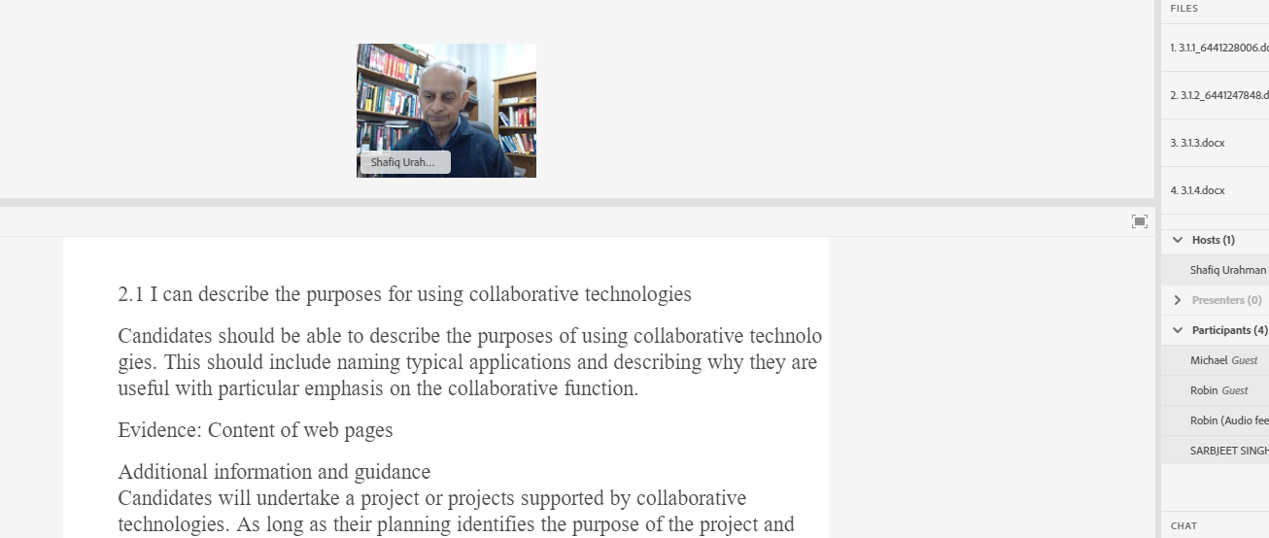

***A screenshot from a previous learning session on Adobe connect***

**Comparatively, if a team was working on a short project then it may not be necessary to archive regular and brief standup meetings, as the outcomes may only be to progress matters or allocate resources. Especially if something like a Kanban board shows progress then archiving in the same way may not be needed. Another example might be in confidential meetings – contents of those meetings being archived may present a security risk of some kind.**

**In my work it is very helpful that Microsoft Teams records what has been discussed previously with colleagues, as I would not otherwise remember if I was then following those interactions up at a later date. Meetings can be recorded which can be very helpful for people supervising to review, or again if someone was not at a meeting or webinar for it to be shared with a larger audience.**

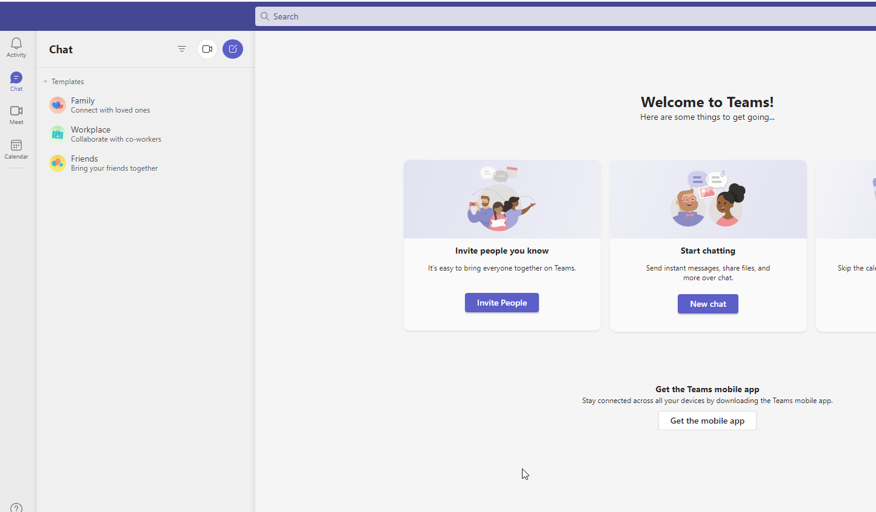

*A screenshot of online-based Microsoft Teams*